**AI MOCK INTERVIEW SIMULATOR:OUTPUT**

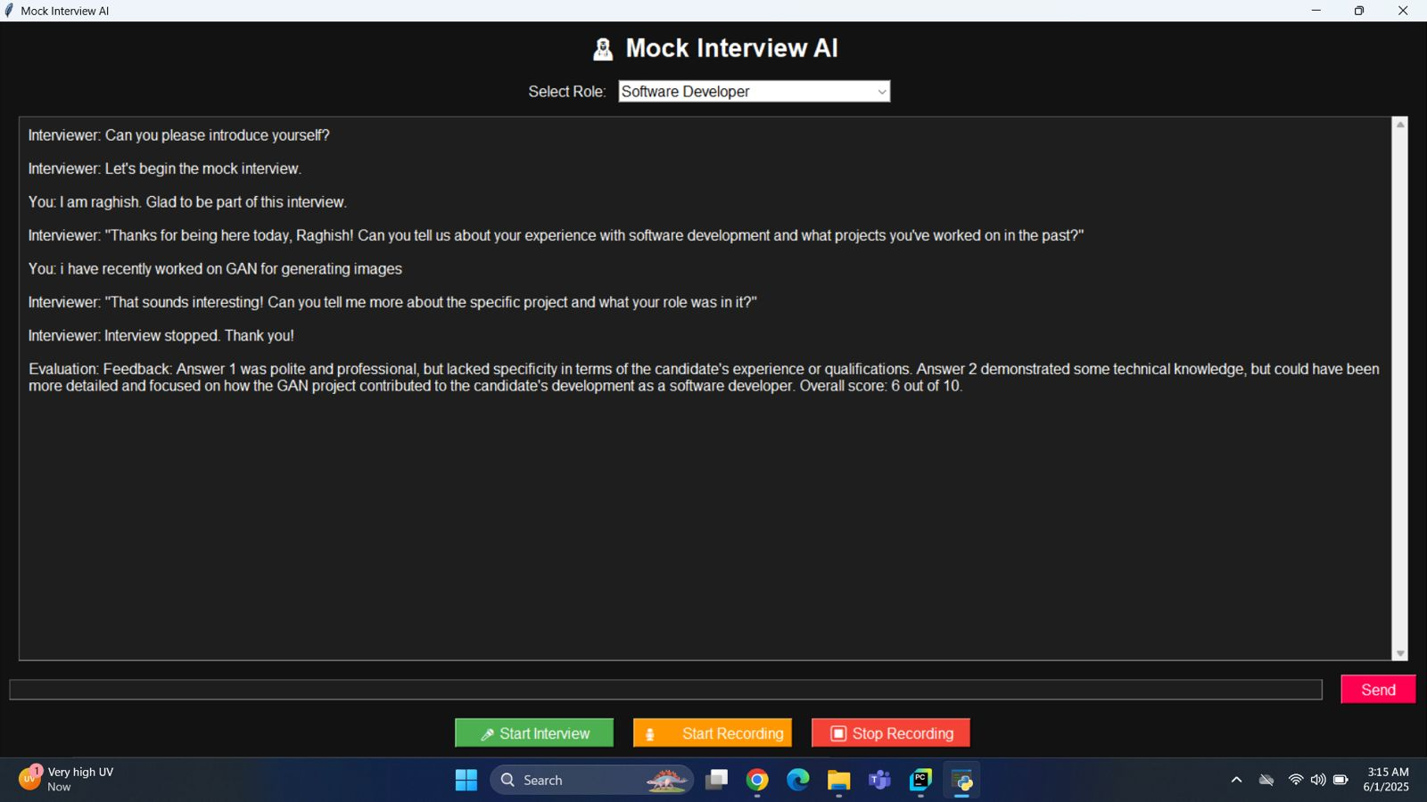

**1.1 DASH BOARD**

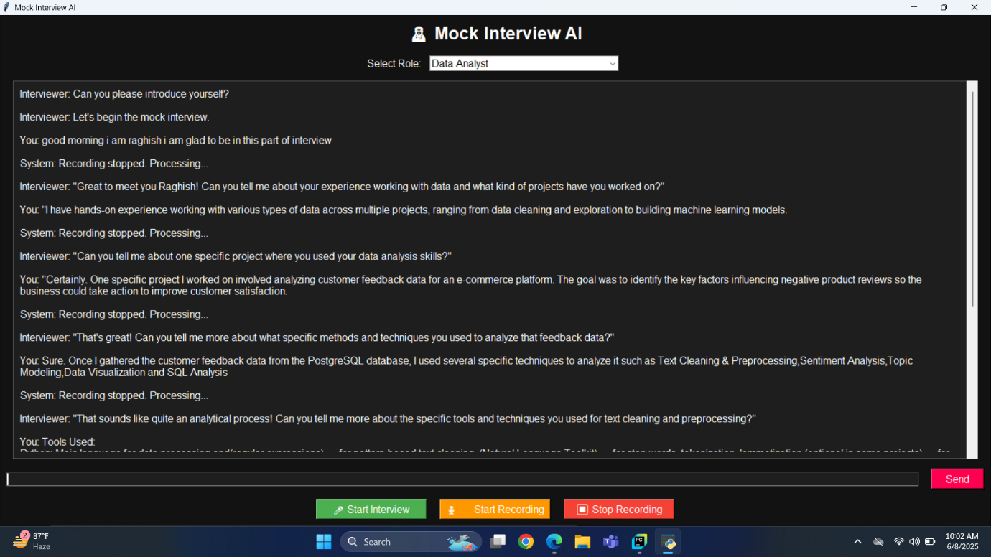

**1.2 INTERVIEW PROCESS**

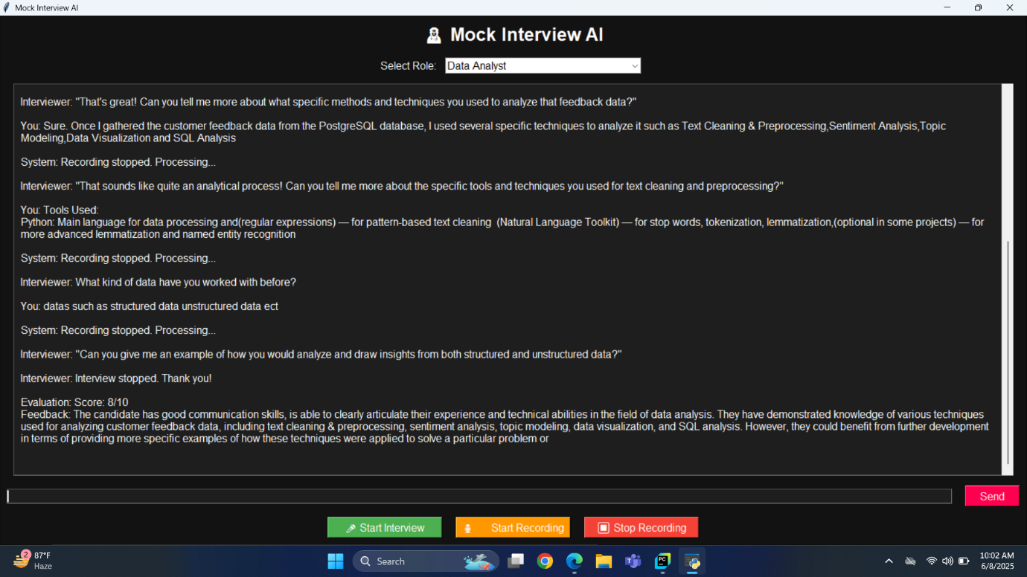

**1.3 FEEDBACK AND SCORE**